# Introduction

We all need clean water to survive, yet is [increasingly becoming scarce](https://thewaterproject.org/water_scarcity) on the planet. While architects and engineers have gotten much better at how to reach Net Zero Energy (NZE) with buildings, Net Zero Water (NZW) remains more of a mystery. The critical issue with “water neutral” as it stands is the term, and related terms, are ambiguous. Different private firms, towns, or water utilities define it differently; as a result, the phrase is in danger of losing any meaning it might have, and becoming little more than a way to market products. This report intends to define the “Net Zero Water” term for our semester project and explains in depth the tasks completed and in progress, for 30% concept design submission, to achieve NZW system for Mehran University of Engineering and Technology.

The first section of the report discusses the design criteria and detailed calculation to estimate the water budget and amount of water reuse for the Jatoi hostel building, MUET Jamshoro. All the input data to calculate water budget was readily available through our contacts. Few assumptions were imperative to take for the calculations, and those are (a) rainfall data of Hyderabad was used as there is no gage station in Jamshoro city, (b) fixture rates are not taken from the regional authority, it is based upon Capital Development Authority, Islamabad. This task is completed. For the part related to water reuse, for this submission, it has yet not been completed. The main hurdles for this task are to find regulations in Pakistan for rainwater harvesting and gray/black water reuse.

The second section of the report explains the sustainability rating system for this project. We are implementing “Living Building Challenge, Water Petal.” The intent of the Water Petal is to realign how people use water and to redefine “waste” in the built environment so that water is respected as a precious resource. The water petal encompasses the Net Positive Water Imperative which defines that site water utilization and discharge must work in amicability with site hydrology and its environment. 100% of the site's water needs should be provided by caught precipitation or closed loop system with treatment process as needed to maintain water quality that will be used for indoor or outdoor activities. The calculations for net zero water has been completed for the conceptual design stage and it will be modified till the detailed design phase.

The third section of the report discusses the cost analysis (BOQs) for plumbing work, water treatment plant and rainwater harvesting. This is the initial estimate, and it will get refined in the next submission. Life-cycle cost is not calculated yet, which will be provided in the late submission.

# Site Description

This report sets out the basis for conceptual design and schematic for water and wastewater infrastructure of Jatoi Hostel in Mehran University of Engineering and Technology (MUET), Jamshoro. The project is located about 18 kilometers from Hyderabad. The hostel building has approximately 20,000 sq.ft of covered area and 25,000 sq.ft of landscape area in its territory. Climatic conditions are arid; days are hot and dry while nights are cooler. The majority portion of precipitation happens in monsoon season (June to August) with an average rainfall of 3.36”. However, in recent years, there have been several rainfall events that have exceeded the average rainfall in the region. The historical precipitation data for the study region have been provided in Appendix. The only source of freshwater for the study area is from Karachi Canal that is roughly 3km away, and ground water is not favorable for indoor and outdoor usage. The existing stormwater infrastructure is conventional, consisting of the downspout at the roof, which collects rainwater and discharges it into existing municipal drainage system.

## Site Maps

Known location of primary water source overlaid on the aerial photo concerning site area is shown below. The map also provides an overview of open space availability that can be used for gray/black water reuse for irrigation purposes.

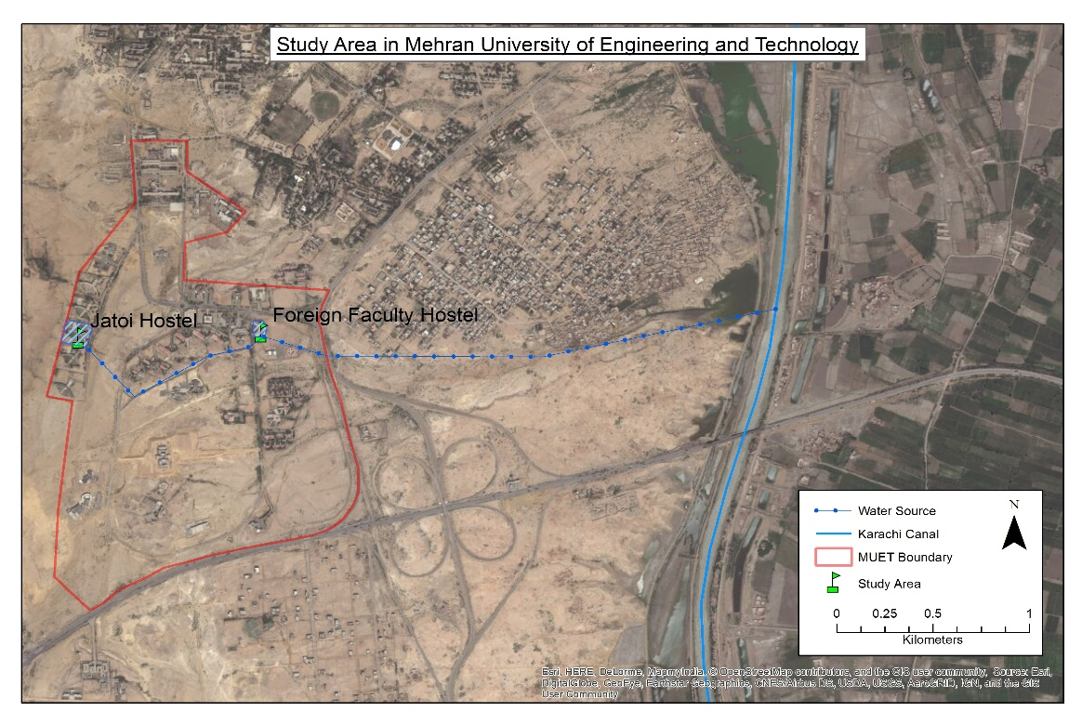

**Figure 1.** Study area location map

# Data Requirements

The initial data requirements for this project was to get the total numbers of a resident at the hostel building. This information was gathered with the help of a formal resident and current exchange student from MUET at U of U, named Azizullah Ghafar. He was the primary source for reconfirming the total number of students from hostel administration. The next step was to get the type of fixtures and their flow rates for accurate estimation of the water budget. This information was collected from Capital Development Authority (CDA), Islamabad and local builders. Lastly, the rainfall data was collected from Pakistan Metrological Department by the help of a Dr. Rasul Bux Mehr (Faculty Member at MUET). Due to unavailability of rain gauge station at the project site, nearby city’s (Hyderabad) precipitation data was used for all the calculation purposes.

## Applicable Authorities & Approvals

The requirements of the relevant local authority shall be adhered to where no applicable standards or guidelines are provided then local standards, international standards, and best practice shall be adopted.

Should conflicts arise during the design out of discrepancies between codes, standards and other documents, the more stringent requirement shall apply. Local authority requirements will usually prevail to ensure compliance and ease of obtaining approvals. Where differing or conflicting standards are used, a unified approach shall be adopted to avoid errors or discrepancies arising from differences in approach, methodology or criteria.

## Services Layout Drawings

The proposed water and wastewater network layout in hostel building has been provided for ground floor which is assumed to be replicated in rest of the building. For conceptual design stage, a typical layout is provided will be modified as the project moves to the detailed design stage. The drawings are attached in Appendix.

## Regulations and Codes

Due to unavailability of local codes and regulations related to our project, mostly international standards and regulation will be applied to carry out all the work. For plumbing work, “International Plumbing Code” (IPC) will be followed. A copy of IPC is attached as Appendix. For rainwater harvesting, “Ontario Guidelines for Residential Rainwater Harvesting Systems” will be used as regulatory guidelines. The copy of this code is also attached in Appendix. Finally, for gray water reuse, “Guidelines for the Reuse of Gray Water” by Prepared by Hawaii State Department of Health Wastewater Branch.

# Model/Calculations

## Water Budget

Water budget calculations are done by using two different tools. First is excel based and the second is python coded (Jupiter interface based) tool. Both tools are required to input a total number of resident, rooftop and landscape area. These tools estimate total indoor and outdoor water demand for the project site. The guidance document by which water budget was determined is attached in Appendix.

# Evaluation Measure

## Living Building Challenge

The Living Building Challenge is an endeavor to significantly increase present expectations from a worldview of doing less harm to one in which we see our part as steward and co-maker of a genuine Living Future. The Challenge characterizes the most exceptional measure of manageability in the assembled condition conceivable today and acts to quickly reduce the crevice between current breaking points and the end-amusement positive arrangements. Living Building Challenge gives a structure to plan, development and the advantageous relationship amongst individuals and all parts of the group.

### Water Petal

The expectation of the Water Petal is to realign how individuals utilize water and to reclassify "squander" in the fabricated condition with the goal that water is regarded as a valuable asset. Shortage of consumable water is rapidly turning into a significant issue the same number of nations around the globe confronted extreme deficiencies and traded off water quality. Indeed, even locales that have kept away from the dominant part of these issues to date because of a chronicled nearness of plentiful crisp water are at hazard: the effects of environmental change, profoundly unsustainable water utilize designs, and the proceeded with the drawdown of real aquifers forecast huge issues ahead.

### Net Positive Zero

Living Buildings must demonstrate that they have achieved Net Positive Water. As a result, Living Buildings harvest, use, and treat all the water that they require without burdening aging municipal infrastructure. In other words, Living Buildings are regenerative; in that, they generate sufficient benefits to the building’s site, to the project’s community, and to the environment at large to offset any negative impacts that the project may incur.

## Site Info

Location – Jamshoro Sindh

Living Transect – L3 Campus Zone

This transect is comprised of relatively low-density mixed-use development

Typology – Building

Occupant Type – Men’s Hostel

## Net Positive Water Imperative

Mehran University of Engineering and Technology is located in the arid region of Sindh. Local average annual precipitation is 3.36 inches with significant portion spread in months of July and August. In this arid environment, Net Zero Water Imperative is a challenging task to achieve. The table below gives an overview of net zero water imperative for the undertaken case study;

Water demand calculations were performed for the building based on building occupancies, scheduled uses and design fixture flow rates to determine the daily water supply for the building.  The design of this building includes several water-saving plumbing devices such as composting toilets, low-flow lavatories, low-flow kitchen sinks and a low-flow shower. All landscaping is native to the region and does not require permanent irrigation.

### Systems Used

**Rainwater Harvesting:** Since achieving Net Zero Water is difficult enough in an arid climate without adding losses from FFDs (known to be relatively water inefficient in practice), the team requested and achieved approval for a design that replaced FFDs with gravel filters at the bottom of each downspout. The gravel filter consists of a 1 square foot by 20 inches deep box filled with three layers of gravel separated by screens that can be accessed and cleaned if needed.

After passing through the gravel filters, harvested rainwater is conveyed via underground plumbing to a centrally located cistern beneath the main garage. The 3,000-gallon cistern was built into the foundation of the garage with its roof functioning as the floor for the garage. Harvested rainwater flows first into an entry chamber where any sedimentation can settle to the bottom.

Collected rainwater passes through two additional filters before it is delivered as water suitable for human consumption. First, microfiltration removes all remaining suspended solids and finally, an ultraviolet (UV) disinfection unit ensures the water is sanitary and free of pathogens.

**Flow diagram of the water treatment process:** In this project the main goal is to make the building net zero in terms of water. That can be achieved only with the help of water reuse. Here in the building two types of water being generated, gray water and black water. Where black water needs more purification, gray water needs less purification. The logic behind this is simple. Black water contains all the solid biological waste that being generated from the toilet and the gray water is the relatively pure water generated mainly form the sink or after shower. Again it is expensive to treat a large volume of water up to the potable water grade. So we will treat only that much water up to the potable grade which is needed. Again black water is the direct sewage water and has a higher biological demand and contamination level. So that we are not mixing that water with the gray water which has far less biological demand and contamination level. To do so we are maintaining two separate pipelines for gray water and black water.

As per the water budget calculation 2000gallon of water per day need to be treated where 200 gallon of water will be consumed as drinking water. So 200 gallons of water should be treated as the potable water grade and the rest of 1800gallon of water will be treated as non-potable grade. Here for the treatment mechanism activated sludge system has been chosen to make sure rapid and low power intensity system. The area of the treatment plant will be around 17000ft2. There are three main sections of this treatment process for black water. Mechanical treatment, Biological treatment and the disinfection. On the other hand, Gray water will receive only the mechanical treatment and the disinfection.

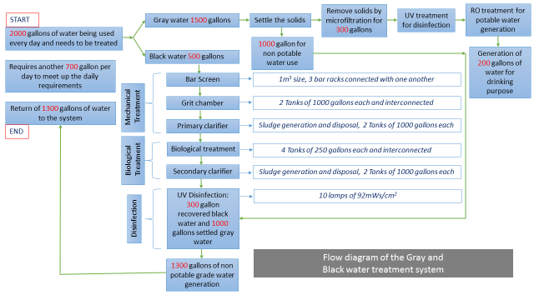

**Figure 2.** Water treatment process flow diagram

**Gray water treatment steps:**

**Settle the solids:** Here a tank of 2000 gallon will be used for the solid settling. For the gray water most of the solid waste will be removed by this system. The heavy solids will be accumulated at the bottom of the system and the relatively fresh water will be settled at the top. From the bottom solids will be removed and from the top relatively clear water will pass to the next step for the microfiltration.

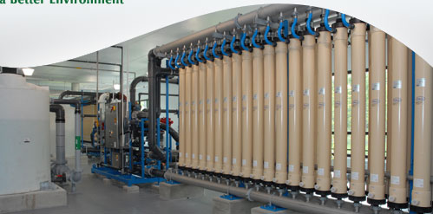**Removal of solids by microfiltration:** Next step is the microfiltration. The main reason for this microfiltration is to make sure that there are no solid particles remains in the water. As the ultimate target is to purify this water up to the potable grade so that no remaining solid particle is not acceptable.

**UV treatment:** The main purpose of this UV treatment is the disinfection. Only two bulbs are required for 300 gallons of water. This bulb is the similar kind of bulb that will be used after the black water treatment.

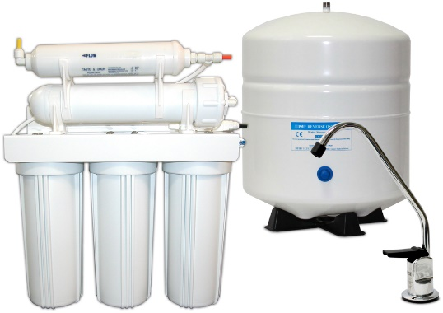

**RO treatment:** Reverse osmosis the final stage of the purification to ensure the optimum water quality to declare that as the potable water. Separate RO system will be used here for this purpose.

**Black water treatment steps:**



**Figure 3.** Gray water treatment flow diagram

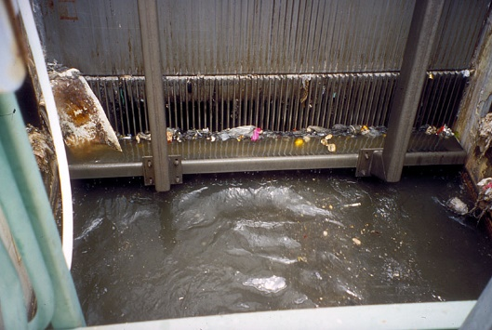**Bar Screen:** Influent from the sewer district must first bypass some type of mechanical treatment. For that bar screen is a mechanical filter that removes an assortment of large solids from the wastewater prior to further treatment. In addition, this process removes non‐digestible materials and fragments biodegradable particles into smaller pieces. Mechanically cleaned bar racks will be used to reduce operating costs and improve screening capacity of the plant. The continuous belt type will be used, as it can remove fine and coarse solids, and will be continuously self‐cleaning. In our project the main concert will be the biological waste generated from the toilets. 1m2 size of 3 bar racks are connected with one another in our system.

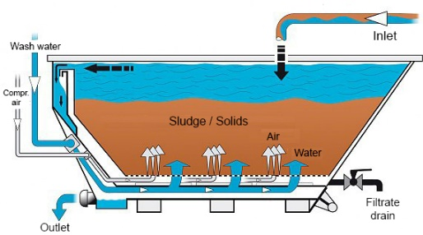**Grit Chamber:** Aerated grit chambers are utilized to settle larger solids that would damage subsequent treatment systems, including: egg shells, coffee grounds, sand, and glass particles. The wastewater enters the grit chamber after it has passed through the bar screen, and is designed to facilitate the settling of solids by inhibiting flow. But typically there should not be any objects like egg shell or other non-degradable plastics in our system. So again the main target will be to reduce the biological waste form the system. 2 tanks of 1000 gallons each are connected with one another in our system.

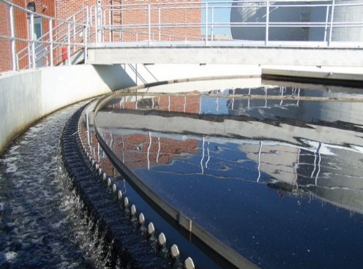**Primary clarifier:** Following the pretreatment process, wastewater is pumped into the sedimentation tanks, also known as the primary clarifiers. The main objective is to further remove additional solids, and skim any grease on the surface of the tank. Given the extended detention time, suspended solids will readily settle, and the tanks are equipped with mechanically driven scrapers that continuously drive the collected sludge towards the center. This is the last step in the mechanical treatment. 2 tanks of 1000 gallons each are connected with each other in this system. By product of this step is the sludge generation. This sludge can be used as the fertilizer in the field. By selling this fertilizer in the field we can reduce the payback time for the whole project.

**Biological treatment:** This step is basically used for the removal of Biological oxygen demand (BOD), nitrogen and phosphorus from the waste water. 4 conjugative tanks in the following sequence: Anaerobic, aerobic anoxic and aerobic are arranged to reduce the biological oxygen demand of the system. The interesting fact about this system is that with the BOD removal this system is also capable of reducing the nitrogen and phosphorus from the system. 4 tanks of 250 gallon each are connected.

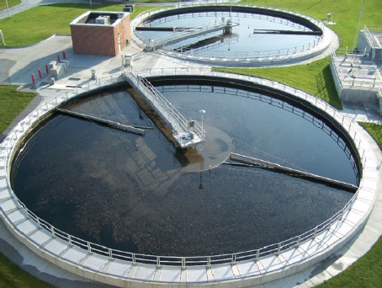**Secondary clarifier:** It is needed after biological treatment to further reduce solids and BOD by settling and concentrating mixed liquor suspended solids (MLSS). The water is then pumped to disinfection, where it is treated for microorganisms and discharged. This is the last step of biological treatment. There should not be any visible clump formation in the water by this step. Most of the biological solids should be removed by now. Only to kill any possible microorganisms, UV disinfection is applied. Again like the primary clarifier two tanks of 1000gallons are connected with one another for the final sludge removal. Like the primary clarifier here also the generated sludge can be used as fertilizer.

**UV disinfection:** Ultraviolet (UV) disinfection inactivates microbes, which increases the quality of the discharged effluent. No sludge will be produced, which will reduce the amount of waste generated by the plant. In addition, no residual chlorine is required in the effluent (this 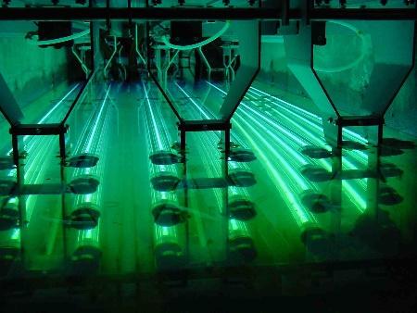is only required for water treatment facilities). UV disinfection is also a safer alternative to chlorine, and will result in space savings and reduced contact time. 10 lamps of 92mWs/cm2 are used here in our treatment system for the final water disinfection.

In our on-site treatment plant there will be 2000 gallon of water received every day and after treatment there will be 1300 gallons of water back to the system. So that means 700 gallon of water will be needed from outside source like rainwater harvesting and central pipelines will be needed to meet the daily requirement.

# Results

The table below shows the results obtained from water budget calculations which take into account rainwater harvesting and potential gray water reuse for domestic and outdoor purposes.

**Table 1.** Water budget calculation results per annum

|  |  |
| --- | --- |
| **Annual water use** | 3,046,719 gal |
| **Harvested onsite** | 67,554 gal |
| **Water cistern size** | 3,000 gal |
| **Collection strategies** | Rainwater for domestic use |
| **Systems fed** | Canal - interior domestic use |
| **Graywater** | 2,661,838 gal |
| **Systems fed** | Irrigation of landscaped area |
| **Blackwater** | N/A |
| **Systems fed** | Composting toilets (Proposal) |
| **Estimated total water use, per capita** | 3,478 gallons (actual) |
| **Stimulated/Designed** | N/A |
| **Design tool(s) & calculation method(s)** | Water estimations |

# Cost Estimate

**Table 2.** Initial cost estimate

| **DESCRIPTION** | **QUANTITY** | **TOTAL COST** | |
| --- | --- | --- | --- |
| **SCHEDULE A - MOBILIZATION & SITE PREPARATION** | |  |  |
| Equipment Mobilization | LS* | $3,500.00 | |
| Labor Mobilization | LS | $2,500.00 | |
| Site Marking & Safety Signs | LS | $1,000.00 | |
| **TOTAL SCHEDULE A** | | **$7,000.00** | |
| **SCHEDULE B - PLUMBING WORKS** | | | |
| Excavation and backfilling for all Pipes Works | LS | $5,000.00 | |
| PPR Water supply pipes | LS | $8,000.00 | |
| UPVC Sewrage pipes | LS | $9,500.00 | |
| All pipe specials such as bends, junctions, elbows, tees, etc. | LS | $2,250.00 | |
| Valves and flow meters | LS | $6,000.00 | |
| Testing & commissioning the entire installation | LS | $2,000.00 | |
| **TOTAL SCHEDULE B** | | **$32,750.00** | |
| **SCHEDULE C - WATER TREATMENT PLANT** |  |  |  |
| Oil & Grease trap | EA* | $4,750.00 | |
| Equalization tank | EA | $15,000.00 | |
| Sand Filter & Activated Carbon filter | EA | $9,500.00 | |
| Chlorinator | EA | $7,500.00 | |
| Sludge holding tank | EA | $5,750.00 | |
| Filter press | EA | $4,000.00 | |
| Piping and Cabling | EA | $8,500.00 | |
| Final treated effluent tank | EA | $10,000.00 | |
| **TOTAL SCHEDULE C** | | **$65,000.00** | |
| **SCHEDULE D - RAINWATER HARVESTING COMPONENTS** | | | |
| 3,000 Gallon Cistern | EA | $15,000.00 | |
| Sump with Transfer Pump | EA | $7,000.00 | |
| Gutter with Gutter Screens | LF | $6,500.00 | |
| Prefilter | EA | $1,250.00 | |
| Insulated Enclosure & Isolation Valve | EA | $750.00 | |
| Booster Pump with Controls | EA | $6,000.00 | |
| Bag Filter | EA | $100.00 | |
| 2" Backflow Preventer, RPBA | EA | $650.00 | |
| Automated Valve | EA | $150.00 | |
| 6" Storm Drain Pipe | LF* | $1,500.00 | |
| 2" Pressurized Rainwater Pipe | LF | $2,375.00 | |
| **TOTAL SCHEDULE D** | | **$41,275.00** | |
| **SCHEDULE E -FINISHING** |  |  |  |
| Clearing spaces and cleaning | LS | $3,000.00 | |
| **TOTAL SCHEDULE E** | | **$3,000.00** | |
|  | **TOTAL - ALL SCHEDULES** | **$149,025** | |
| **CONTINGENCY (20%)** | **$29,805** | |
| **Sales Tax @8.7%** | **$2,593** | |
| **TTOTAL ESTIMATE INCLUDING SALES TAX** | | **$181,423** | |

*LS is lump sum; EA is each and LF is labor force